Pinwheels and Pie Crusts!

Pastry for Pies, Tarts, and Cookies
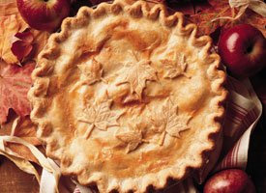

2 cup Gold Medal® all-purpose flour
1 teaspoon salt
2/3 cup plus 2 Tablespoon shortening
6 to 7 Tablespoons cold water or more if needed
- Unbaked One-Crust Pie Crust: Mix flour and salt in medium bowl. Cut in shortening, using pastry blender (or pulling 2 table knives through ingredients in opposite directions), until particles are size of small peas. Sprinkle with cold water, 1 tablespoon at a time, tossing with fork until all flour is moistened and pastry almost leaves side of bowl (1 to 2 teaspoons more water can be added if necessary).
Gather pastry into a ball. Shape into flattened round on lightly floured surface.
Roll pastry, using floured rolling pin, into a circle.
Pinwheels
Ingredients:
½ to 1 C. Sugar
½ T. Cinnamon
¼ C. Milk
Pie Dough (Previously made)
Directions:
Once you have finished making the above pie crust recipe you will –
- Preheat oven to 400* F
- Combine sugar and cinnamon in a pyrex cup – do not add the milk to this
- Brush the rolled out pie crust with milk to create a thin sheen – do not use it all if you do not need to
- Evenly sprinkle sugar mixture across the milk brushed pie dough
- Roll the pie crust up tightly to create a cylinder, then slice into ½ inch slices
- On a greased sheet pan bake the pinwheels at 400* F for 12 – 15 minutes
- Remove from sheet pan and cool

