Dietary Guidelines and My Plates

Go to – www.choosemyplate.gov

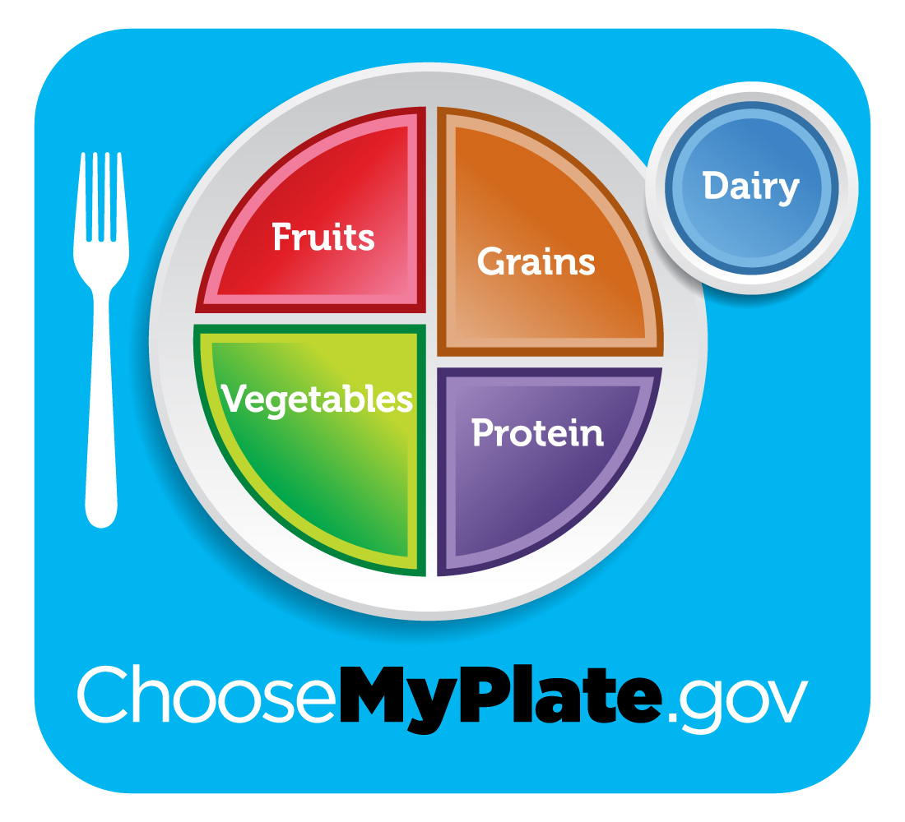

Bread, Cereal, Rice and Pasta - GRAINS
- this group includes all kinds of grain products
- they supply complex carbohydrates, fiber, B-vitamins and incomplete proteins
- grains - should be largest portion of your diet
- serving size examples include - 1 slice bread, 1 oz. cereal, (dry cereal varies by volume; 1 oz. can vary from 1/2 cup to 1 cup); 1/2 cup cooked cereal, rice, or pasta; a typical bagel would be 2 - 3 servings
- most teenage boys need (11 servings) and most teenage girls (9 servings)
- to get adequate fiber choose as many whole grain foods as possible

Vegetables
- vegetables provide fiber, complex carbohydrates and are low in fat
- vegetables supply vitamins A, C, and K
- different vegetables provide different nutrients; select a variety of different types of vegetables
- it is recommended daily servings including dark green and yellow/orange vegetables
- serving size examples include - 1 cup raw leafy vegetables, 1/2 cup cooked or chopped raw, 3/4 cup vegetable juice

Fruits
- fruits contain - complex carbohydrates, are low in fat and sodium, high in fiber
- many fruits are high in vitamin C and potassium
- be sure to have at least one serving from fruits rich in vitamin C - such as citrus fruits, melons, and berries
- eat fresh fruits often for the fiber they provide; edible skins are good sources of fiber
- select canned or frozen fruits without added sugar
- serving size examples include - 1 medium fruit; apple, banana, or orange, 1/2 cup chopped, cooked or canned fruit; 3/4 cup fruit juice - only count 100% fruit juice as a serving of fruit; fruit beverages and fruit drinks contain less than 10% juice

Milk, Yogurt and Cheese - DAIRY
- youth up to age 24, pregnant and breast feeding women should consume 4 servings daily
- milk group foods are high in complete proteins, usually fortified with vitamins A & D
- milk products are excellent sources of calcium, phosphorus, and riboflavin
- low fat choices include skim milk, nonfat yogurt, low-fat cheeses, etc.
- these foods are critical for maintaining and growing healthy teeth and bones
- there foods along with weight bearing exercise are essential for maintaining bone density
- ice cream and cheese are higher in fat than some other dairy selections; skim milk is non fat
- serving size examples include - 1 cup milk or yogurt, 1 1/2 oz. natural cheese, 2 oz. processed cheeses

Meat, Poultry, Fish, Dry Beans, Eggs and nuts - MEATS
- these foods provide an important source of complete proteins, B vitamins and minerals, including iron
- select lean meats, fish, and poultry without skin to reduce fat
- dry beans, split peas, refried beans, pork and beans, chili, and lentils are high in fiber
- nuts are a higher fat protein source
- serving size examples include - 2 - 3 oz. of cooked lean meat, poultry or fish or about the size of a deck of cards; 1 serving is also equivalent to: 1/2 cup cooked dry beans, one egg or 2 Tbs. peanut butter
1 egg, 2 Tbs. peanut butter and a 3 oz. serving of chicken would be
equal to 3 servings

Nutrients Study Sheet

Carbohydrates
- primary function - provide energy
- carbohydrates have 4 calories per gram
- simple and complex carbohydrates
- simple carbohydrates - are also called sugars
- complex carbohydrates - are also known as starches
- carbohydrates - good sources include whole grains, cereal products, dried beans, rice, pasta

Proteins
- primary function - builds and repairs body tissues
- lack of protein - stunts growth and slows healing
- kwashiorkor – disease caused by the lack of protein in a diet
- energy source is 4 calories per gram
- complete and incomplete proteins
- 22 amino acids - the building blocks of protein
- 9 of the 22 essential - the body can’t manufacture them from other amino acids
- complete proteins contain all 9 of the essential amino acids; come from animal sources
- amino acids - basic structural unit of protein
- incomplete proteins come from plant sources; can be combined to create a complete protein; i. e. rice and beans, peanut butter with whole wheat bread
- meat contains the essential amino acids, protein, and iron
- tofu from soybeans is the only complete protein from a plant source

Fats
- function - carrier of vitamins A, D, E, and K; reserve supply of energy; adds flavor in food; satisfies hunger creating satiety as it remains in the stomach longer; protects internal organs from shock and injury; insulates the body from shock and temperature changes
- concentrated source of calories; 9 calories per gram
- 66 grams - recommended maximum number of grams of fat for a 2000 calorie diet; no more than 30% of total calories; no more than 10% of total fat (22 grams) come from saturated fat; 20% (44 grams) should be from monounsaturated and polyunsaturated fat sources
- high fat diets are linked to heart disease, obesity, and cardiovascular related problems
- cholesterol
- Cholesterol is essential for many body processes; cholesterol produces hormones and bile acids; it is found in animal tissues, but is never present in plants
- body has HDL (good) cholesterol and LDL (bad) cholesterol
- high levels of LDL cholesterol is one factor related to heart disease and obesity
- body manufactures cholesterol in the liver
- For individuals without any risk factors, the National Cholesterol Education Program recommends the following goals: less than 200 mg/dl for total cholesterol, less than 130 mg/dl for LDL, and greater than 35 mg/dl for HDL.
- The average American consumes about 350-450 mg. of cholesterol every day with fat being about 35-40 percent of total caloric intake. Recommended consumption levels are less than 300 mg. of cholesterol with fat being 30 percent of total calories.
- There are several controllable factors that can influence cholesterol levels, exercising more can decrease the LDL levels while increasing HDL levels. The best type of exercise of lowering cholesterol is aerobic exercise. Other factors to consider include weight control and diet.
- saturated, mono-unsaturated and poly-unsaturated fats
- saturated fats come from animal sources and are solid at room temperature
- saturated fats raise the LDL and HDL levels of cholesterol in the blood
- examples include - meat, poultry skin, whole milk, tropical oils, butter, shortening, lard
- monounsaturated fats lower LDL and raise HDL levels of cholesterol in the blood
- examples include - olive oil, olives, avocados, peanuts, canola oil

- polyunsaturated fatty acids - lowers both the LDL and HDL cholesterol levels in the blood
- examples include - corn oil, soybean and safflower oil

Fiber
- National Cancer Institute recommends 20 - 35 grams of fiber in the diet
- fiber - roughage, attracts water to our intestines, moves food through the intestines faster
- fiber helps to keep bowel movements soft in form; reduces problems related to constipation
- cellulose - is nondigestible fiber
- examples of foods high in fiber - fruits, vegetables, whole grains, legumes, bran cereals, dry beans, split peas, lentils
- need to drink plenty of liquids; otherwise fiber can slow down or even block bowel function
- add fiber to a recipe - bananas, raisins, berries, and replacing part of flour with whole wheat flour
- fiber reduces the risks of diverticulosis, colon and rectal cancer

Water
- water carries vitamin C and B complex vitamins in the body; carries waste products through the body; regulates body temperature through perspiration
- water - most important of all the essential nutrients
- body can’t survive long without water
- dehydration occurs from lack of water
- water is contained in most foods
- prevent dehydration - drink water and other fluids frequently - don’t wait to be thirsty (thirst is an indication of dehydration)
- 8 - 8 oz. glasses of water are recommended daily
- urine should be a pale yellow color (color of lemonade); darker urine is one indication of dehydration
Vitamins
- vitamins assist in the biochemical reactions related to the metabolic process
- vitamins A, C and E are antioxidants; antioxidants are substances that react with oxygen to protect other substances from harmful effects of oxygen exposure
- A - enhance hair, skin, and vision
- night blindness
- B - complex (thiamin, riboflavin, niacin, folate (also called folacin in the past; folic acid is the synthetic form of this vitamin nutrient supplements and fortified foods) B-6, B-12 - impact on the nervous system and releases energy from fats, carbohydrates, and proteins
- Women of childbearing age who have inadequate folate intakes are more likely to give birth to babies with neural tube damage. This damage affects the brain and spinal cord and can cause mental retardation, paralysis and premature death. Research confirms that folic acid reduces the risk of neural tube damage and is recommended to have 400 micrograms daily.
- thiamin (B1) - beriberi
- riboflavin (B2) - cheilosis
- niacin - pellagra
- C - helps to form collagen which holds the cells together, aids in healing; antioxidant (antioxidants bind oxygen reducing the amount of oxygen available to damage other molecules)
- chemical name - ascorbic acid - scurvy
- D - manufactured by the body with exposure to sunlight; works with minerals to build, maintain healthy bones and teeth; usually added to milk products
- sunshine vitamin - rickets
- E - is an antioxidant
- miracle drug
- K - helps blood to clot
- water soluble: C, B-complex
- cannot be stored in the body, must be consumed daily
- water-soluble vitamins - C and B group

- fat soluble: A, D, E, K
- excessive consumption of fat soluble vitamins can be harmful and lead to toxicity
- fat soluble vitamins - A, D, E, K

- functions and food sources
- refer to handouts

Minerals
- most minerals become part of the body, i.e. bones and teeth
- others are used to make substances that the body needs
- usually needed in tiny amounts, but are critical to health
- Macro Minerals - calcium, phosphorus, magnesium
- macro minerals are those minerals in greater quantity in the body
- calcium - osteoporosis - bones gradually lose their minerals becoming weak and fragile
- Electrolytes - sodium, potassium, chloride
- electrolytes - help maintain the fluid balance in the body, help maintain the heartbeat, help muscle and nerve action
- electrolytes easily become imbalanced in cases of dehydration, illness, and diarrhea
- Trace minerals include: iron, iodine, zinc, fluorine (fluoride), etc.
- trace minerals are those minerals needed in lower quantities in the body; they are just as important as the macro minerals in function
- iron - anemia - low red cell formation; low blood count
- iodine - goiter
- fluorine - teeth carries

- Functions and food sources
- refer to handouts

- Common Mineral Deficiencies in the US
- calcium - osteoporosis - bones gradually lost their minerals becoming weak and fragile; good sources are in dairy products, select low-fat options
- iron - anemia, low red cell formation; low blood count; animal products provide excellent sources of iron, select lean types/cuts

